dsoy dk;Zky; iz;ksx gsrq

FOR OFFICIAL USE ONLY



Hkkjr ljdkj
jsy ea=kky;

GOVERNMENT OF INDIA
MINISTRY OF RAILWAYS

OPERATING INSTRUCTIONS TO USE WEB VERSION OF STOP (STOPPING TRAIN ON PNEUMATIC BRAKES) SIMULATION PACKAGE FOR ESTIMATION OF EMERGENCY BRAKING DISTANCE (EBD)

INSTRUCTION BULLETIN NO. MP.IB.BK. 04.14.07 REV. 02
JULY 2009

vuqla/kku vfHkdYi ,oa~~ ekud laxBu
y[kuÅ & 226 011
RESEARCH DESIGNS & STANDARDS ORGANISATION
MANAK NAGAR, LUCKNOW-226011.

No. SD.INV.5 DT. …-07-09
INSTRUCTION BULLETIN NO. MP.IB.BK. 04.14.07 REV. 02

- Title: -

Operating instructions to use Web version of STOP (Stopping Train on Pneumatic Brakes) Simulation Package for estimation of emergency braking distance (EBD).

2.0 Background: -

The STOP (Stopping Train on Pneumatic Brakes) Simulation Package was issued to all Zonal Railways vide this office letter no. SD.INV.5 dt. 16/30.11.07 to cater to the requirements of different Zonal Railways to calculate/estimate Emergency Braking Distances (EBD) of different rolling stocks. Subsequently, the STOP Simulation Package was revised to cover light engine and certain new rolling stocks inducted in Indian Railways, vide this office letter no. SD.INV.5 dt. 29.09/03.11.08.

This software was based on Fortran IV and not very user friendly. With increasing requirements to know EBD for different types of rolling stocks by different railways, it was felt necessary to devise a package, which is more user friendly and is readily available to all Railways for use.

3.0 Object: -

To enable railways to get Emergency Braking Distances (EBD) of different types of rolling stocks in a very user friendly way.

- Application/ Scope: -

To make the STOP Simulation Package more user friendly and for visualization approach, the Web version of STOP Simulation Package has been prepared. This version is not only more user friendly as compared to earlier version of STOP Simulation Package but also provides visualized approach to the user. This Web version of STOP can be readily available on website for use of different Zonal Railways.

This instruction bulletin covers instructions to execute Web version of STOP Simulation Package for estimation of EBD (Emergency Braking Distances). Zonal railways may use this package to calculate EBD for different combinations of locomotives, wagons and coaches.

STOP is not applicable for estimation of speed, grade, brake power percentage, brake cylinder pressure or no. of vehicles etc. for a specified EBD value and Zonal Railways should not use STOP for such estimation. STOP Simulation Package is meant only for estimating EBD for a given set of specified condition.

This software is to be used for estimating EBD of typical trains running on Indian Railway. Following special cases of estimation of EBD are not covered by the present software and any such requirements may be referred to Motive Power Directorate of RDSO for estimation of EBD: -

  - Vacuum braked train
  - Meter gauge and narrow gauge trains
  - Steam locomotives of all gauges
  - Trains consist with loco brake ineffective.
  - Any other specific trains consist, locomotives, wagons or coaches having different (non standard) values of brake development time and time lag rigging efficiency and cylinder efficiency.
  - Train containing more than one type of brake blocks i.e. fitted with mixture of CI, ’L’ or ‘K’ type blocks.
  - Accident relief train containing break down crane
  - Multiple types of wagons or any combination of goods train and coaching stock.
  - Estimation of EBD at the end of controllability run down the ghat section, when dynamic brake/partial air brake is used for controlling the speed of train down the ghat.

Note: - In case of item 4.1 to 4.3, Zonal Railways may use the earlier software ‘EBDCI’ circulated to all Zonal Railways vide this office letter no. SD.INV.5 dt. 03/06.01.2006.
- Instructions: -

To execute this software, user has to log on http//10.100.3.212:8000/ebd. On logging, the screen will appear as under: -
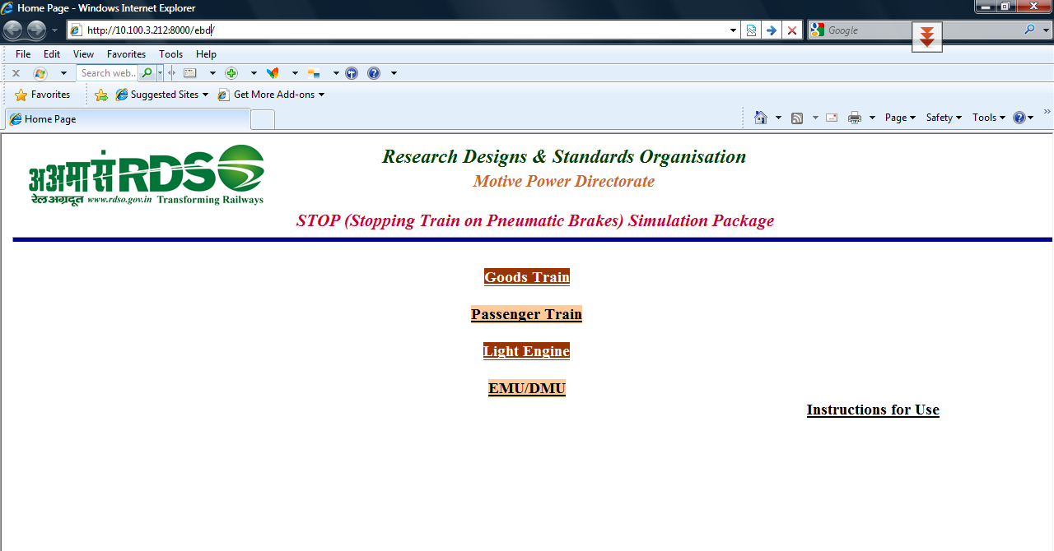

Now, user can select any option by clicking the respective buttons as described in the next paragraphs.

  - Goods train: -

On clicking “Goods Trains” button, following the screen will appear as under for EBD calculation of any goods train covered by this version of STOP simulation package: -
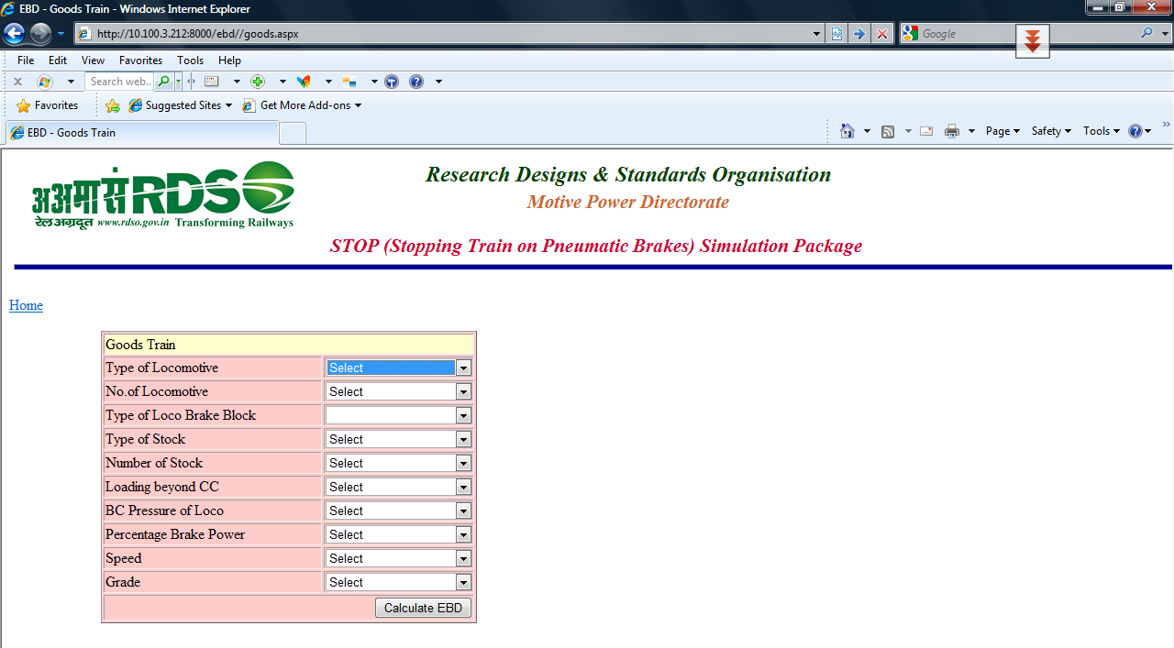

On clicking on the arrow of respective combo box, a dropdown list will appear as shown below: -
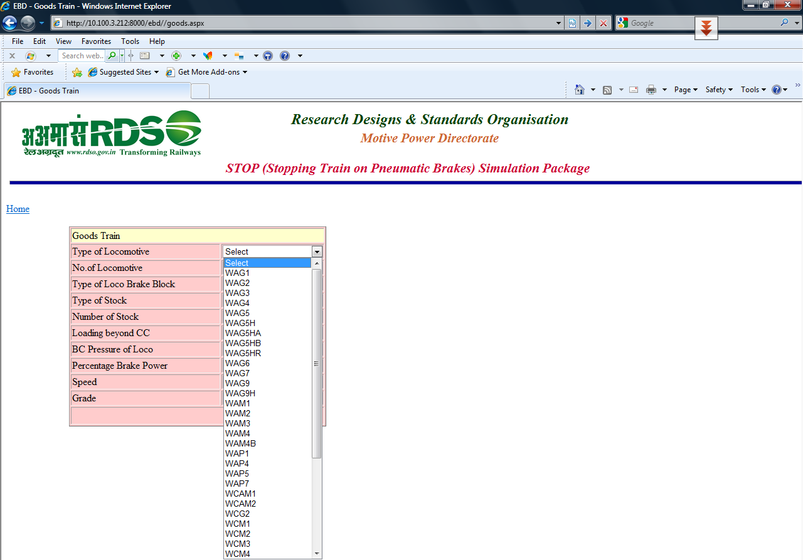

Input data can be selected one by one by clicking respective combo box and then click on command button named as calculate EBD. Now, EBD will appear on screen as under: -
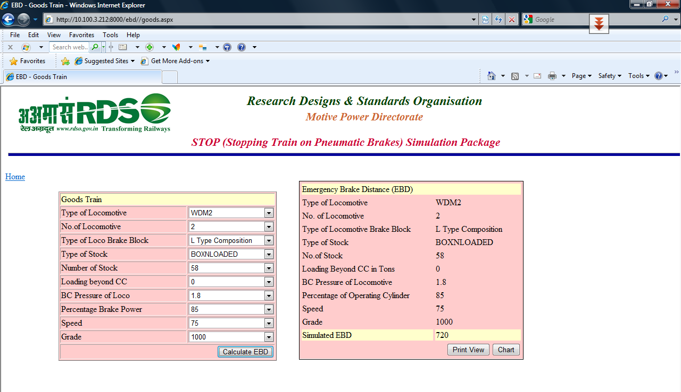

On clicking print view, the print view will appear on the screen, which can be exported as PDF file in users computer as else it can be printed also. On clicking chart, user will get a graph between time versus speed and distance on the screen, which can be exported as PDF file in users computer or can be printed also.
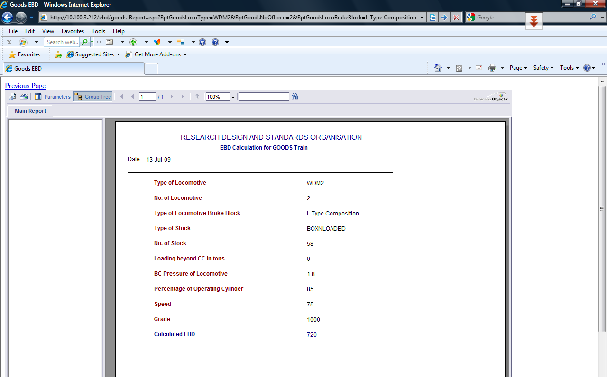
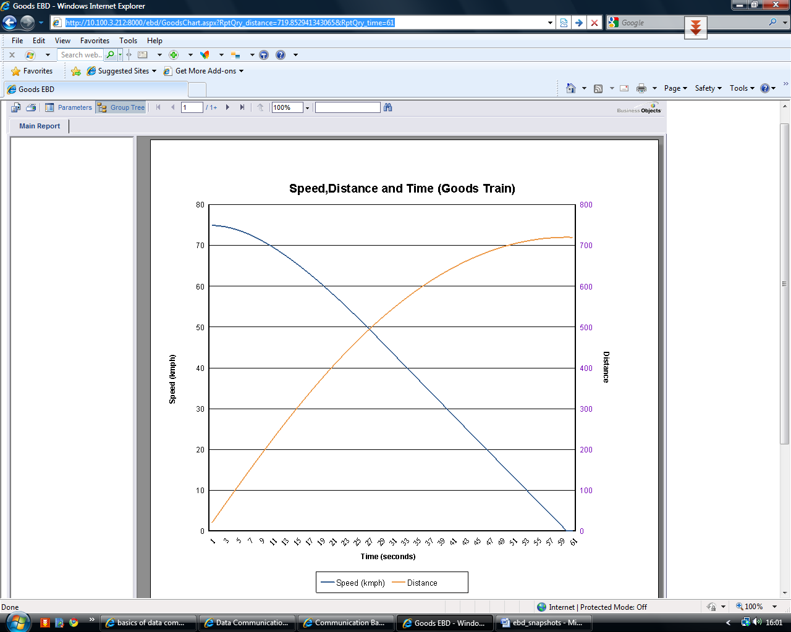
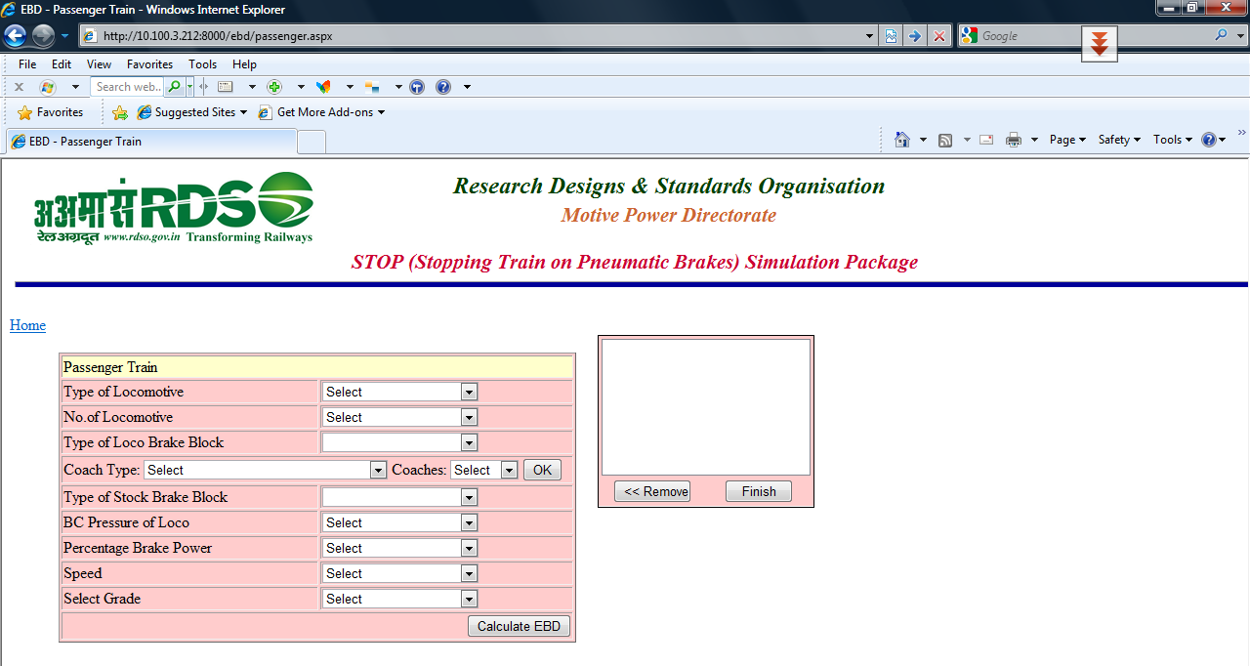

  - Passenger train: -

On clicking “Passenger train” button, following dialogue box will appear for EBD calculation of any Passengers train covered by this version of STOP simulation package: -

The selected coach type and their respective no. will appear in the small dialogue box on clicking “OK” command button. User must have to click “Finish” command button before calculating EBD. Any undesired coach type can be removed on clicking “Remove” command button.

The EBD values will appear on clicking “Calculate EBD” command button as already described above in para 5.1.

  - Light Engine: -

On clicking “Light Engine” button, following dialogue box will be appear for EBD calculation of any Light Engine covered by this version of STOP simulation package: -
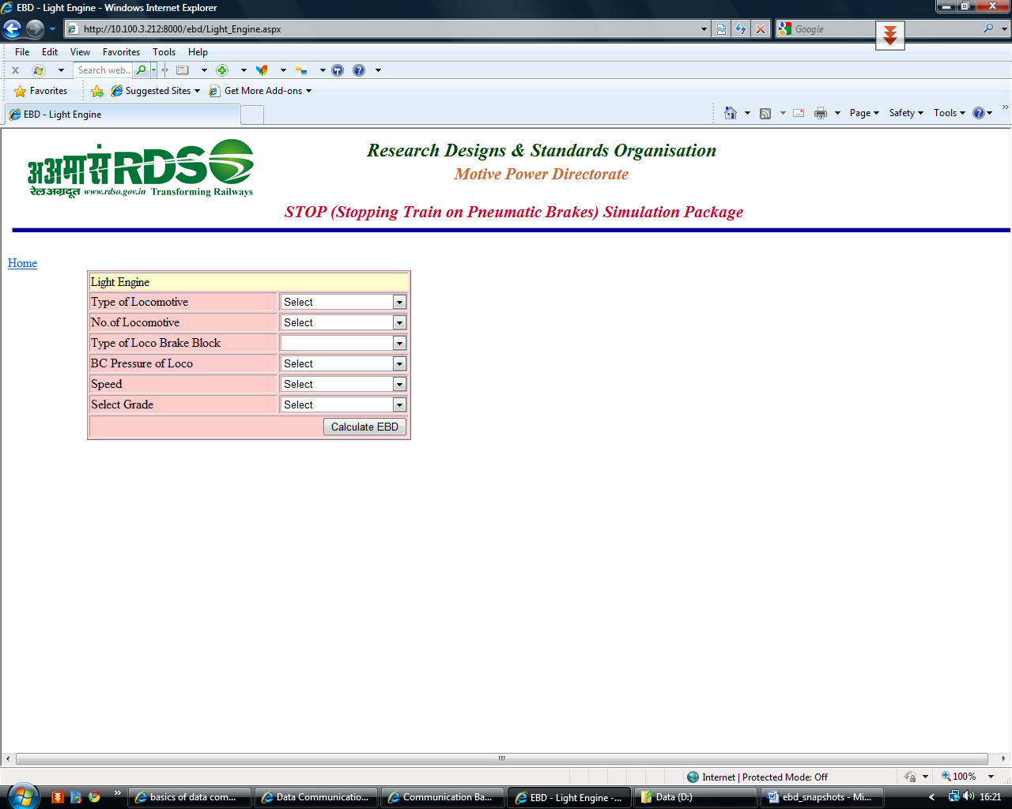

  - EMU-DMU: -

On clicking “EMU-DMU” button, following dialogue box will be appear for EBD calculation of EMU, DMU & MEMU trains covered by this version of STOP simulation package: -

  - General Guidelines for the use of software: -

    - The EBD values obtained by ‘STOP’ should be used as guidelines only as they may vary depending upon the reliability and accuracy of data input. The input data should invariably be in accordance with the maximum permissible load and speed for that type of rolling stock and section as per applicable speed certificates issued by RDSO. In case, it is necessary to ascertain the correct value of EBD, field trials may be conducted and results may be validated.

5.5.2 Data assumption

The data such as brake development time, brake cylinder pressure, time lag, rigging and cylinder efficiency of stock and percentage of operative cylinder may vary depending upon the train consist. General assumptions for these data are as under: -

5.5.2.1 Brake development time and time lag: -Brake development timing and time lag for estimation of EBD for various combinations of trains has been a problem for Zonal railways due to non-availability of field trial report for a particular train consist. These values have to be assumed accurately otherwise there would be variation in EBD results.
To resolve the above problem, the following values indicated in the table are to be considered for onward feeding of data for estimation of EBD based on the field values available for brake development timing. These are rationalized values in seconds and may vary slightly from field values.

Train Combination | Locomotive | First | Last | Remark
Loco + 10 coach | 13 | 5 | 6
Loco + 12 coach | 13 | 5 | 8
Loco + 14 coach | 13 | 5 | 10
Loco + 16 coach | 13 | 5 | 12
Loco + 18 coach | 13 | 5 | 14
Loco + 20 coach | 13 | 5 | 16
Loco + 22 coach | 13 | 7 | 19
Loco + 24 coach | 13 | 7 | 22
Loco + 26 coach | 13 | 7 | 25
DMU/EMU/MEMU | - | 3.5 | 7 | EP Brake
Loco + 58 BOXN / 40 BCN / other goods train of standard loop length | 20 | 26 | 34
Light Engine | 5 | - | -

The above value of brake development timing along with standard values of such data as time lag, rigging and cylinder efficiency has been set as default value in computer software ‘STOP’ to simplify the execution of software, since these data have standard value for air brake wagons and coaches i.e. Rigging and cylinder efficiency of air brake wagons as 80 % and 90% respectively and of air brake coaches as 90 % and 90% respectively. Similarly, time lag for first and last stock of air brake standard trains of the wagons taken as 1 and 3 seconds respectively and of air brake standard trains of the coaches as 1 and 2 seconds respectively

      - Percentage of operative cylinder: -The percentage of operative cylinder means brake power of the trains and may be taken as 95 % for coaching stock and 85 % for goods stock as a general guidelines. For ghat sections, it should be taken as operating instructions specified by Zonal Railways or Railway Board.

5.5.2.3 Brake cylinder pressure: -Brake cylinder pressure of locomotive is maximum brake cylinder pressure of locomotive during Automatic brake application and should be fed according to actual value of the concerned locomotive. Maximum brake cylinder pressure of locomotive during Automatic brake application is as follows: -

Sr. No. | Locomotive | Brake cylinder Pressure | Remarks
 | WDG4 and WDP4 | 4.4 kg/cm² | Likely to be revised to 1.8 kg/cm²
 | WAP5 locomotive | 5.0 kg/cm² | Under revision
 | WAP7 and WAG9 locomotive | 4.5 kg/cm² | Under revision
 | All other diesel electric and electric locomotive | 1.8 kg/cm² | Reduced from 2.5 kg/cm² to 1.8 kg/cm² vide IB no. MP.IB.BK.02.16.08 circulated vide this office letter no. SD.DFM.A.4.7.1 dt. 03.06.08

Similarly Maximum brake cylinder pressure of locomotive during Independent brake application is as follows: -

Sr  No. | Locomotive | Brake cylinder Pressure | Remarks
1 | WDG4 and WDP4 | 5.2 kg/cm² | Under revision
2 | WAP5 locomotive | 5.0 kg/cm² | Under revision
3 | WAP7 and WAG9 locomotive | 4.5 kg/cm² | Under revision
4 | All other diesel electric and electric locomotive | 3.0 kg/cm² | Reduced from 3.5 kg/cm² to 3.0 kg/cm² vide IB no. MP.IB.BK.02.16.08 circulated vide this office letter no. SD.DFM.A.4.7.1 dt. 03.06.08

5.5.3 The dropdown list of all combo boxes has been prepared taking into consideration the present operation of Indian Railways. However provision has been kept in the dropdown list itself whereby a user can know EBD for any specific values of fields like BC pressure of locomotive, % brake power, speed or grade.

5.5.4 In the software, it has been considered that WDG4 / WDP4 and WAP5 locomotives are fitted with high friction brake block or ‘K’ type disc brake respectively. Similarly WAG9 /WAP7 locomotive are fitted with cast iron brake blocks. All other locomotives covered in ‘STOP’ may be fitted with cast iron or ‘L’ type composition brake blocks. Accordingly, the EBD software ‘STOP’ has provision of selection of type of brake blocks fitted on all locomotives (i.e. whether a locomotives is fitted with cast iron brake block or ‘L’ type composition brake blocks) except WDG4 / WDP4, WAP5 and WAG9/WAP7 locomotive.

5.5.5 It has been considered that all LHB / GARIB RATH Coaches, DMU, EMU & MEMU are fitted with ‘K’ type brake blocks only. All other Coaches covered in ‘STOP’ may be fitted with cast iron, ‘L’ type composition brake blocks or ‘K’ type brake blocks. Accordingly, the EBD software ‘STOP’ has provision of selection of type of brake blocks fitted for all Coaches except LHB / GARIB RATH Coaches DMU, EMU & MEMU.

6.0 Additional Information:-

If there is variation from the conditions as mentioned above, RDSO should be approached for guidance. If any further clarification is required regarding STOP simulation package, the same can be referred to Motive Power directorate.

7.0 Agency for Implementations:-

All Zonal railways headquarters.

8.0 Distribution:-

All Zonal railways headquarters

9.0 Reference: -

Earlier version of STOP simulation package issued vide this office letter no SD.INV.5 dt. 29.09/03.11.08.

(N.K. Barnawal)
For Director General/MP

